**Subject**: Web Development **Lesson**: DOM

**Class**: Grade 10 & 11 **Time**: 2 Sessions (100 minutes)

**Date**: 00/00/2017 **Teachers**: M. Al-Musawi, R.Damaj & R.Khalil

**Purpose of the Lesson:**

The main purpose of this lesson is to demonstrates what is DOM and how to manipulate the it.

**Objectives**:

After completing this lesson, you will:

1. Learn what DOM stand for.
2. Learn about the DOM structure.
3. Learn how to change the style from JavaScript.
4. Learn how to save the value of input inside a variable.
5. Learn how to display the text from JavaScript into the webpage.

**Terms:**

Document Object Model, function, submit.

**Session:**

1. Define JavaScript HTML DOM.

When a web page is loaded, the browser creates a **D**ocument **O**bject **M**odel of the page.

<https://www.w3schools.com/js/js_htmldom.asp>

1. DOM structure.

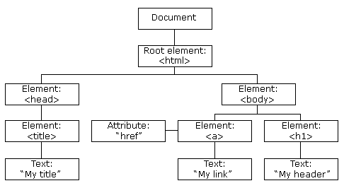

1. How DOM useful in creating a dynamic Web-Site.

With the object model, JavaScript gets all the power it needs to create dynamic HTML:

* JavaScript can change all the HTML elements in the page
* JavaScript can change all the HTML attributes in the page
* JavaScript can change all the CSS styles in the page
* JavaScript can remove existing HTML elements and attributes
* JavaScript can add new HTML elements and attributes
* JavaScript can react to all existing HTML events in the page
* JavaScript can create new HTML events in the page

1. DOM Methods.

HTML DOM methods are **actions** you can perform (on HTML Elements).

HTML DOM properties are **values** (of HTML Elements) that you can set or change.

<https://www.w3schools.com/js/js_htmldom_methods.asp>

**Exercise:**

Create a web-site at takes the first and last names of a person and display the full name on the webpage.

**Requirements:**

1. Must be styled well with CSS.
2. Must have two inputs one for the first name and other for the last name.

